# Modes of Music

## Definition

**# Source**: **Chatgpt (GPT-5-Standard) at [10/26/2025]**

**Modes of music** refer to the **different scales or patterns of notes** that form the foundation of a melody.  
Each mode has its own **unique sound, mood, and emotional effect**.

In simpler terms:

A **mode** is a way of organizing the notes in music to create a certain **feeling or atmosphere** — happy, sad, calm, mysterious, etc.

## Modes of Music (with Historical Development)

### 🎼 1. Natural / Primitive Modes

**# Source**: **Chatgpt (GPT-5-Standard) at [10/26/2025]**

(Prehistoric Era – before 5000 BC)

* **Description:** The earliest form of musical sound organization used by prehistoric humans (like Neanderthals).
* **Characteristics:** Unstructured tones, natural pitches, simple rhythms, and vocal or flute-like sounds based on instinct.
* **Example:** Neanderthal bone flute sounds, primitive chanting.

### 🎼 2. Western (Greek / Church) Modes

**# Source**: **Chatgpt (GPT-5-Standard) at [10/26/2025]**

(Ancient Greece → Medieval Europe)

These are the **seven traditional modes** used in Western classical and modern music.  
They’re based on the white keys of a piano (C to C, D to D, etc.), but can start on any note.

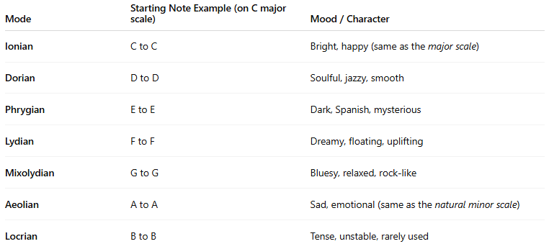

| **Mode** | **Starting Note Example (on C major scale)** | **Mood / Character** |
| --- | --- | --- |
| **Ionian** | C to C | Bright, happy (same as the *major scale*) |
| **Dorian** | D to D | Soulful, jazzy, smooth |
| **Phrygian** | E to E | Dark, Spanish, mysterious |
| **Lydian** | F to F | Dreamy, floating, uplifting |
| **Mixolydian** | G to G | Bluesy, relaxed, rock-like |
| **Aeolian** | A to A | Sad, emotional (same as the *natural minor scale*) |
| **Locrian** | B to B | Tense, unstable, rarely used |

### 🌍 3. Indian Classical Modes (Ragas)

**# Source**: **Chatgpt (GPT-5-Standard) at [10/26/2025]**

(Ancient India – over 2000 years ago)  
In Indian music, **Ragas** are melodic frameworks or modes used to express specific **moods, times of day, or seasons**.  
There are hundreds of ragas, but here are a few famous ones:



| **Raga Name** | **Mood / Time of Day** |
| --- | --- |
| **Raga Yaman** | Peaceful, evening |
| **Raga Bhairavi** | Devotional, early morning |
| **Raga Desh** | Joyful, monsoon season |
| **Raga Bhimpalasi** | Romantic, afternoon |
| **Raga Darbari Kanada** | Serious, emotional, night |

### 🏺 4. Middle Eastern Modes (Maqamat)

**# Source**: **Chatgpt (GPT-5-Standard) at [10/26/2025]**

(Ancient Mesopotamia / Arabic Tradition)

In Arabic and Middle Eastern music, **Maqam** (plural: *Maqamat*) are modes that define the scale, melodic development, and emotional tone.



| **Maqam Name** | **Mood / Feel** |
| --- | --- |
| **Maqam Hijaz** | Mysterious, spiritual |
| **Maqam Rast** | Balanced, noble |
| **Maqam Bayati** | Warm, expressive |
| **Maqam Nahawand** | Sad, emotional (similar to minor scale) |
| **Maqam Kurd** | Dark, reflective |

### 🐉 5. East Asian Modes

**# Source**: **Chatgpt (GPT-5-Standard) at [10/26/2025]**

(Ancient China, Japan, Korea)

Traditional East Asian music often uses **pentatonic (5-note) scales** as modes.



| **Culture** | **Mode / Scale Name** | **Mood / Character** |
| --- | --- | --- |
| **Chinese** | Gong, Shang, Jue, Zhi, Yu | Various emotional tones using 5-note systems |
| **Japanese** | In scale, Yo scale | Calm, meditative, or emotional |
| **Korean** | Pyeongjo, Gyemyeonjo | Peaceful or sorrowful tones |

### 🎧 6. Modern / Contemporary Music Modes

**# Source**: **Chatgpt (GPT-5-Standard) at [10/26/2025]**

(Renaissance → Today)

Modern composers and producers sometimes refer to **modes** more broadly as **moods or tonal centers** in genres like jazz, rock, and film scoring.

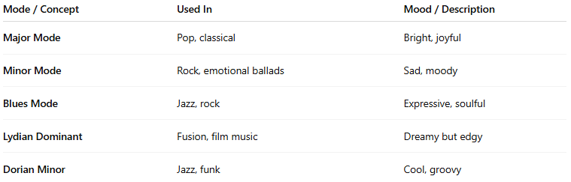

| **Mode / Concept** | **Used In** | **Mood / Description** |
| --- | --- | --- |
| **Major Mode** | Pop, classical | Bright, joyful |
| **Minor Mode** | Rock, emotional ballads | Sad, moody |
| **Blues Mode** | Jazz, rock | Expressive, soulful |
| **Lydian Dominant** | Fusion, film music | Dreamy but edgy |
| **Dorian Minor** | Jazz, funk | Cool, groovy |

## Examples of Modes

**# Source**: **Chatgpt (GPT-5-Standard) at [10/26/2025]**

1. **Natural / Primitive Mode (Prehistoric Era)**  
   → *Bone Flute Sounds* — early human music made from natural pitches and vocalizations; raw, instinctive, and unstructured.
2. **Western Mode:**  
   → *Dorian Mode* — used in jazz and blues for its smooth, soulful sound.
3. **Indian Classical Mode (Raga):**  
   → *Raga Yaman* — peaceful and often played in the evening.
4. **Middle Eastern Mode (Maqam):**  
   → *Maqam Hijaz* — has a mysterious, spiritual feeling.
5. **East Asian Mode:**  
   → *Yo Scale (Japanese)* — creates a calm and gentle atmosphere.
6. **Modern / Contemporary Mode:**  
   → *Blues Mode* — expressive and emotional, common in jazz and rock music.

## 🧠 In Summary

**# Source**: **Chatgpt (GPT-5-Standard) at [10/26/2025]**

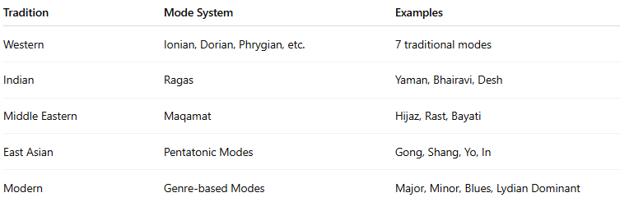

| **Tradition** | **Mode System** | **Examples** |
| --- | --- | --- |
| Western | Ionian, Dorian, Phrygian, etc. | 7 traditional modes |
| Indian | Ragas | Yaman, Bhairavi, Desh |
| Middle Eastern | Maqamat | Hijaz, Rast, Bayati |
| East Asian | Pentatonic Modes | Gong, Shang, Yo, In |
| Modern | Genre-based Modes | Major, Minor, Blues, Lydian Dominant |